Category-Informative
Company-SysTools Group
Keyword-Import MBOX to Gmail

Keywords:
import mbox to gmail, import mbox file into gmail, mbox file format, import mailbox to gmail, import mbox to gmail, mbox email, open mbox file, how to open mbox files, mbox to gmail, upload mbox to gmail, how to upload mbox file to gmail, how to import MBOX to Gmail, MBOX format to Gmail

Extra Keyword:
import mbox gmail,

How to Import MBOX to Gmail
Nowadays a lot of users send and receive emails through Gmail. It is a popular email client because it has dedicated folders, labels, and filters. It also provides proper email management through Social, Updates, Promotions and Forums tabs. Generally, when users want to migrate from their old email client to Gmail, they want to import their old emails. While migrating from applications like Thunderbird, Eudora, Windows Live Mail, etc., users have their old emails in the MBOX file format. Users want to upload files or folders of emails in the MBOX format to Gmail. Therefore, In this blog, we will discuss how to import MBOX to Gmail.

Need to Import Mailbox to Gmail
Many users want to migrate from their existing email client to Gmail because it provides advanced features like free cloud storage. But, they need to import their old emails into Gmail for a smooth transition. Since these emails are generally in the MBOX format, users need to upload MBOX to Gmail. Sometimes, users want to import old Gmail emails (of MBOX format) back into the mailbox. This can be understood better with the user queries sourced from a forum:

“Till a few days ago, I was using Thunderbird as my primary email application. But, recently a friend told me about Gmail’s benefits. For my ease, I will start using Gmail when I have imported my old emails to it. Since they are in the MBOX format, I need to know how to upload MBOX file to Gmail. ”

“When I set-up my new Windows computer, I started using the Gmail service. But, because I was using Eudora for Mac, I exported all my emails as MBOX. It would be handy if I could synchronize my emails in Gmail. Does someone know how to open MBOX files in Gmail?”

Method to Import MBOX File into Gmail
The process of exporting MBOX emails into Gmail is not direct. Some users would propose to forward the emails, but that is a time-consuming process. Some emails may be left behind. Therefore, users need to install Thunderbird on their computer systems to import MBOX to Gmail. Because Thunderbird is a light and simple application that supports the MBOX file format. The steps are mentioned below.
- Enable IMAP settings of the target Gmail ID.
- Open MBOX files/original email ID in Thunderbird.
- Set up Gmail ID in Thunderbird. Drag and save emails to the new account. When Gmail is opened later, the copied emails start to appear in Gmail.

Step 1: Enable Gmail IMAP settings
Enable IMAP on the Gmail address you wish to add the MBOX emails as follows:
- Download Thunderbird on your computer and install it.
- Sign into your Gmail account.
- To make sure that Gmail can be synchronized with another application. Click on Settings >>Settings.
- Open the Forwarding and POP/IMAP tab. In IMAP Access section, select Enable IMAP>> Save Changes.
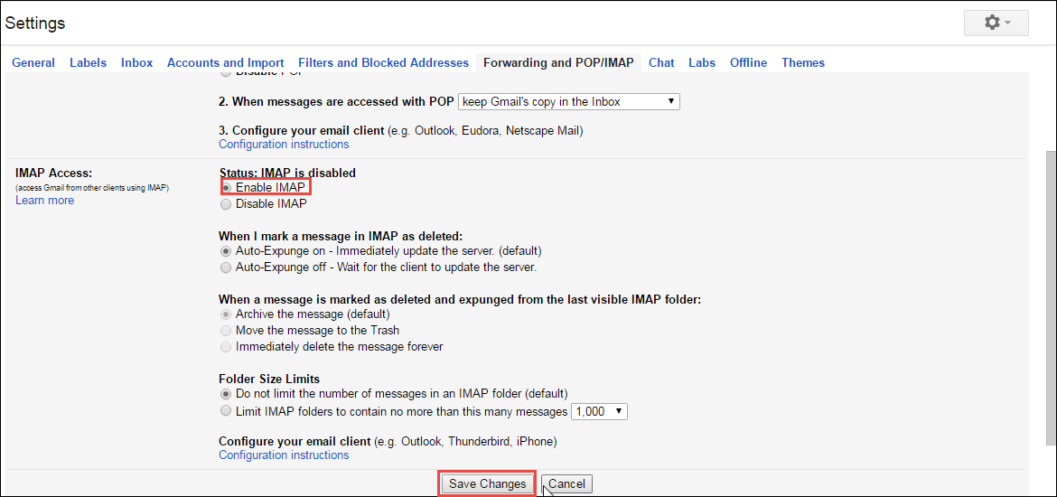

Step 2- Set up Gmail in Thunderbird
- Open Thunderbird. Right click on Local Folders and go to Settings.
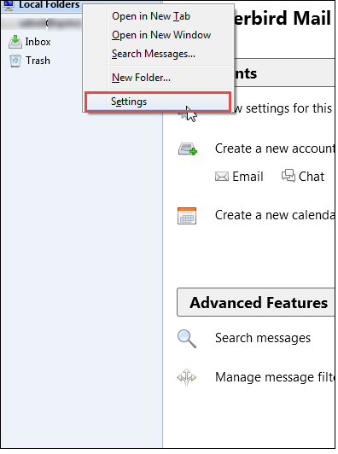

- Click Account Actions on bottom left, and select Add Mail Account.

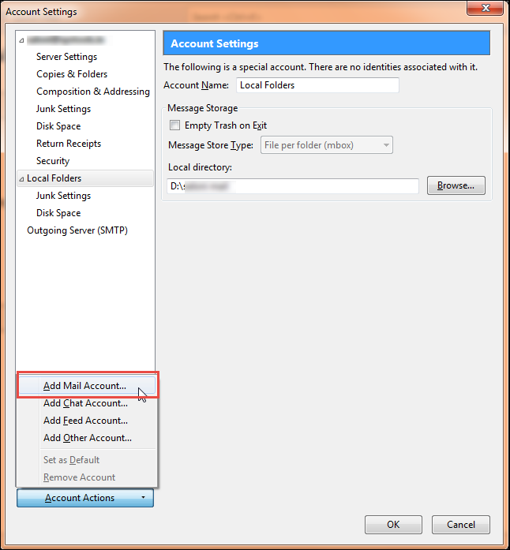

- In the new window, enter your Name, Email ID, and password to the email address. Click Continue.

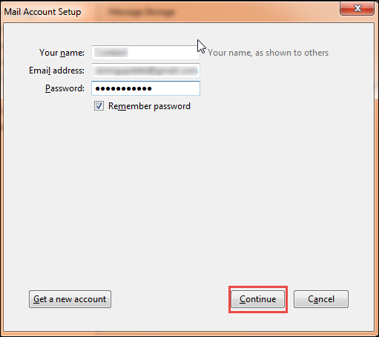

- Choose IMAP(remote folders) button and click on Done.
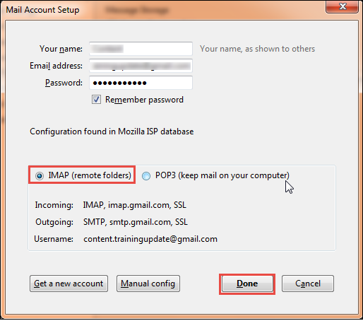

- Click on Browse to change the directory of the folder location. If the location is correct, click OK.
- The new email ID appears in the left panel. Double-click on it, to see your emails in Thunderbird.
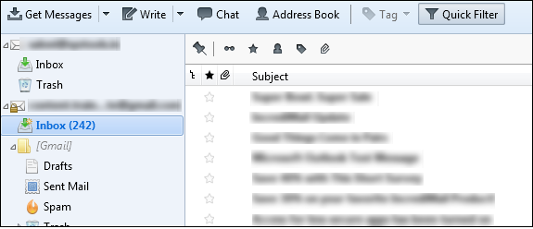
This way, users can set up both the source and target email address in Thunderbird. The next step will import MBOX to Gmail.
Step-3: Import MBOX messages to new Gmail Inbox in Thunderbird
- Select the emails you want to import. Press Ctrl+A to select all the messages.
- Right click. Select Copy To. Select the New Gmail ID and the target folder.
Users can also copy to specific folders using the drag and drop method.
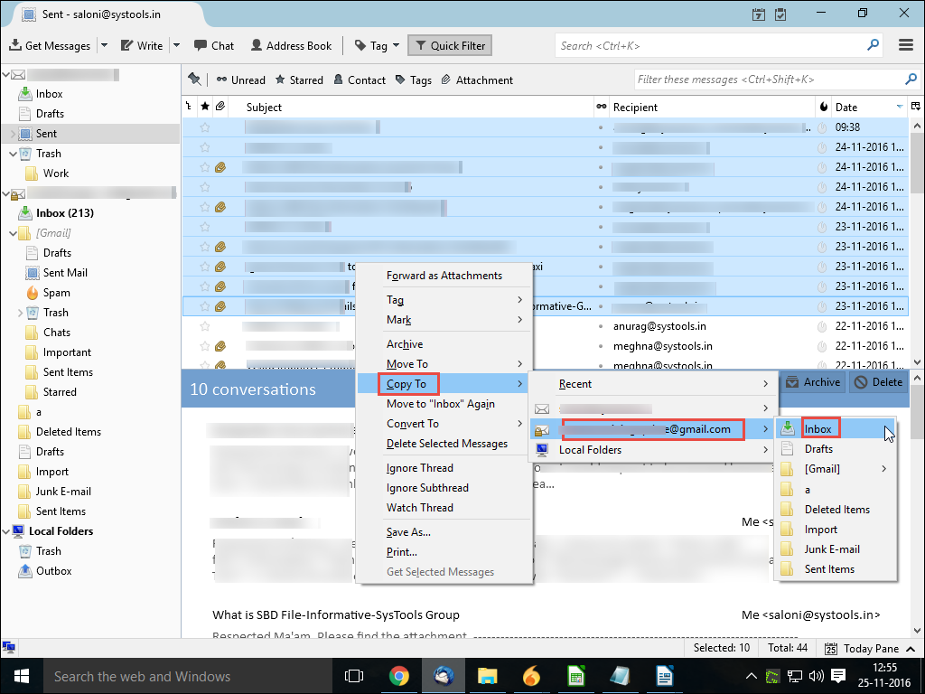
- When you open Gmail in the browser, the copied emails will be visible in the Gmail mailbox as well.
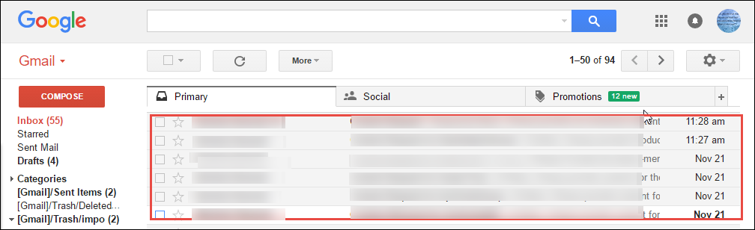

Using Gmail’s IMAP settings, the mails from one mailbox can be synchronized with the Gmail mailbox using Thunderbird. Therefore, when users wonder how to import MBOX to Gmail, this method can be followed. It is an indirect method to open MBOX file but simple for even non-technical users.

Conclusion
Gmail is a popular client because it provides free cloud storage, and good email management with tabs, labels and more. Consequently, a lot of users are migrating from their existing email client to Google. Because users need their old emails and data, they look for ways to import them to Gmail. Since most email clients save their data in the MBOX file format, users want to know how to import MBOX to Gmail. Therefore in this blog, we explained the steps to import MBOX file into Gmail. It can be accomplished through Mozilla Thunderbird that can access MBOX email. Users can set up both email addresses and directly copy the desired emails to the Gmail account. It is an indirect method but can be followed even by novice users.

